**Task 1**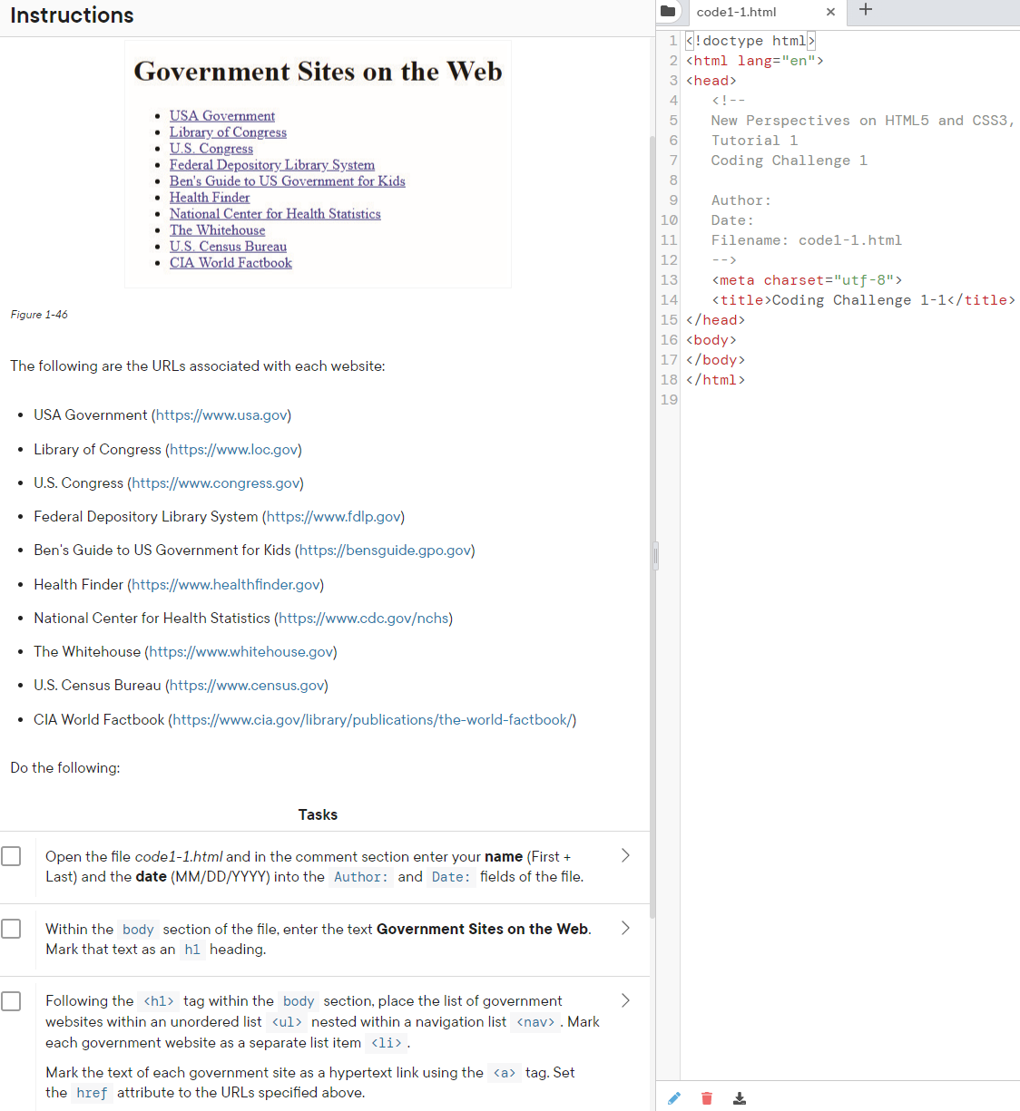

**Task 2**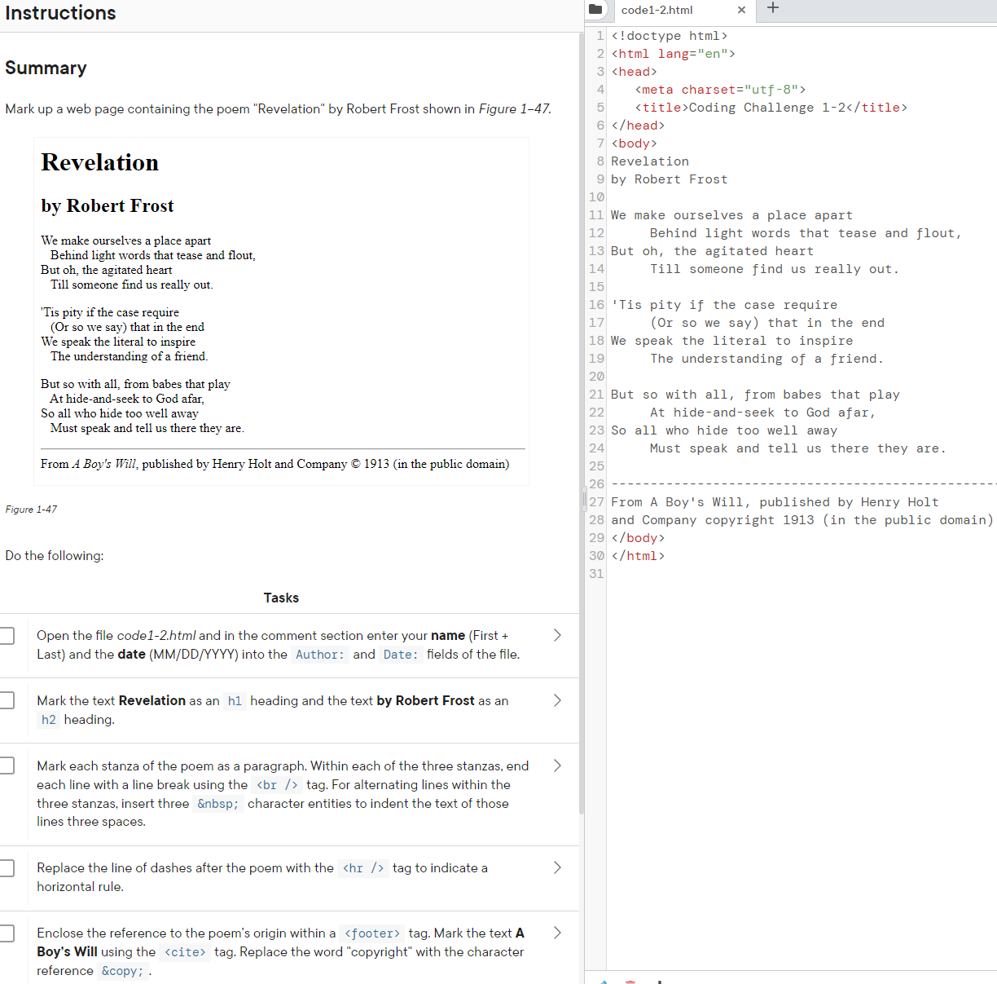

<!doctype html>

<html lang="en">

<head>

   <meta charset="utf-8">

   <title>Coding Challenge 1-2</title>

</head>

<body>

Revelation

by Robert Frost

We make ourselves a place apart

     Behind light words that tease and flout,

But oh, the agitated heart

     Till someone find us really out.

'Tis pity if the case require

     (Or so we say) that in the end

We speak the literal to inspire

     The understanding of a friend.

But so with all, from babes that play

     At hide-and-seek to God afar,

So all who hide too well away

     Must speak and tell us there they are.

-------------------------------------------------------------------

From A Boy's Will, published by Henry Holt

and Company copyright 1913 (in the public domain)

</body>

</html>

**External CSS**

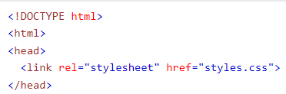

**Internal CSS**

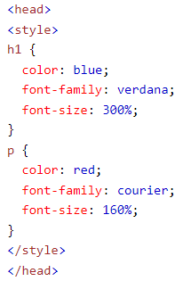

**Meta Tags**

Information about the data. Goes inside the head element. Not displayed on the page

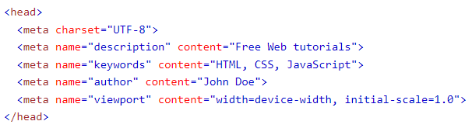

**Img Tags**

The <img> tag is used to embed an image in an HTML page. Images are not technically inserted into a web page; images are linked to web pages. The <img> tag creates a holding space for the referenced image. The <img> tag has two required attributes:

* src - Specifies the path to the image
* alt - Specifies an alternate text for the image, if the image for some reason cannot be displayed



**Task 3**

